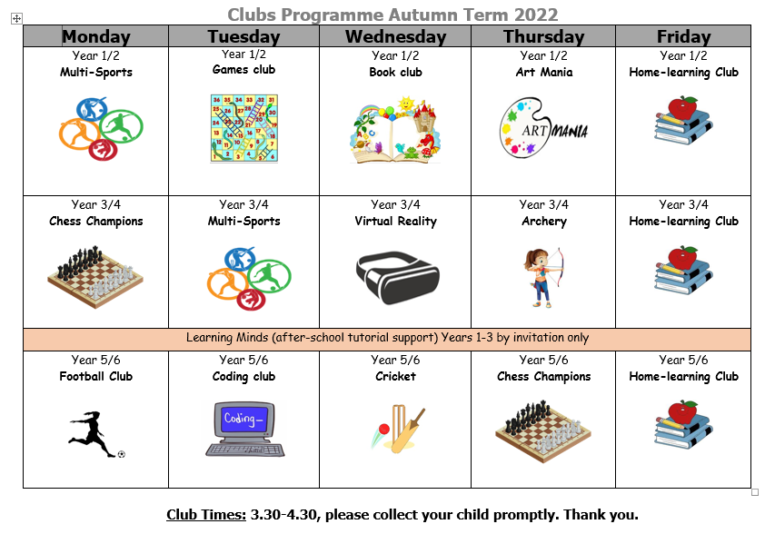

PLEASE USE THE FOLLOWING LINK TO SIGN UP FOR THE CLUBS:

https://forms.gle/VeCtpCoipqHasJ2R8

What you can expect:

Multi-Sports (Year 1 & 2):
This club will cover a range of activities aiming to reinforce the learning from PE lessons. Children will play a variety of games improving their agility, strength, flexibility and stamina.

Games Club (Year 1 & 2):
Children will get to explore lots of games and make their own. They will plan, design and create wonderful games and of course get to play them!

Book club (Year 1 & 2):
Children will get to enjoy books, become characters, act out stories and much more. Love everything about books…this is the club for you!

Art Mania (Year 1 & 2):
This creative club will focus on lots of fine-motor control skills like cutting, sticking, colouring, folding paper all whilst creating some fantastic artwork!

Home Learning club (Year 1 -6):
This club aims to provide a peaceful learning environment for completing home-learning. This club is particularly designed for children who may not have the right environment at home to concentrate on their learning rather than if a child requires lots of support.

Chess champions (Year 3,4,5&6):
Chess is a game that is nearly 1,500 years old and is a battle of minds. All abilities are welcome in this club as rules, strategy and competition will be covered.

Virtual Reality (Year 3 & 4):
The future is here with Virtual Reality! Step into other worlds at this exciting tech club. This club is for those interested in learning about and using virtual reality through a range of devices. Children will also be learning about internet safety.

Archery club (Year 3 & 4):
Archery is a skilled sport using concentration, strength and hand-eye coordination to try and hit a target. The club will be run in a supervised, safe environment with primary school level equipment.

Football (Year 5 & 6):
Open to girls and boys, football club will develop your skills, use of space, positioning…and who knows, you could be playing for Crystal Palace one day! This club aims to be fun for all abilities and will teach children the social benefits of playing football.

Coding club (Year 5 & 6):
Coding is the term used for computer programming and children will learn the basics and then use their coding knowledge to design their own computer games. Learning to code helps children in many areas of their learning, not just computing!

Cricket (Year 5 & 6):
Cricket is a sport that requires good hand-eye coordination, tactics, throwing & catching skills. Children will gain confidence in bowling, batting, fielding all through fun games. Cricket is also a social sport and a good way to keep healthy.

Learning Minds (Years 1-3):
Learning Minds is small group learning that happens after-school. You cannot sign up for this; selected children will receive a notification through Parent Hub if they have been identified for this support.

